Introduction to Python
Python Overview
• History of Python
• Features and advantages
• Python applications
• Python ecosystem
Environment Setup
• Installing Python
• Installing VS Code/PyCharm
• Using Jupyter Notebook
• Python Interpreter
First Python Program
• Hello World
• Running scripts
• Comments and documentation
Hands-on Labs
▸ Install Python
▸ Execute first program
▸ Simple calculator
Python Fundamentals
Variables and Data Types
• Integer
• Float
• String
• Boolean
• None
Input and Output
• input()
• print()
Type Casting
• int()
• float()
• str()
Operators
• Arithmetic
• Comparison
• Logical
• Assignment
• Membership
• Identity

Hands-on Labs
▸ Temperature converter
▸ Area calculator
▸ Currency converter
Assignment
• Employee salary calculator
Control Statements
Conditional Statements
• if
• if-else
• if-elif-else
• Nested conditions
Looping Statements
• for loop
• while loop
Loop Control
• break
• continue
• pass
List Comprehensions Introduction
Hands-on Labs
▸ Number guessing game
▸ Multiplication tables
▸ Prime number checker
Assignment
• ATM menu system

Introduction to Python
Python is a high-level, general-purpose programming language designed to make software development readable, productive, & relatively easy to learn. It emphasizes readability & simplicity as its syntax is designed so that developers can express programming concepts with relatively little code & without dealing with multiple low-level implementation details.

Python Overview
- What is Python?
  - High-Level Language
  - General-Purpose Language
  - Interpreted Language
  - Dynamically Typed Language
  - Object Oriented Language
  - Muti-Paradigm Language
  - Cross-Platform Language
  - Open-Source Language
- History of Python
Python was created by a Dutch programmer named “Guido van Rossum”.
The development of Python language began in late 1980’s, with it being designed as a successor to the ABC programming language.
The first public version, Python 0.9.0, was released in 1991.
  - Python 0.9 – 1991
  - Python 1.0 – 1994
  - Python 2.0 – 2000
  - Python 3.0 – 2008
- Features and advantages
  - Simple & readable syntax
  - High-Level Language
  - Interpreted execution model
  - Dynamically typed
  - Object-Oriented programming
  - Multi-paradigm programming
  - Extensive standard library
  - Large third-party ecosystem
  - Cross-platform support
  - Open-Source
  - Extensibility
  - Embeddability
  - High developer productivity
  - Rapid application development
  - Strong community
  - Excellent documentation
  - Strong support for modern technologies
- Limitations of Python
  - Performance
  - Memory consumption
  - Limited support for Mobile development
  - Browser-side development
- Python applications
  - Web Development
  - Data Science
  - Artificial Intelligence
  - Machine Learning
  - Automation
  - DevOps
  - Cloud Computing
  - Scientific Computing
  - Testing & QA
  - Cybersecurity
- Python ecosystem
It refers to the collection of tools, libraries, frameworks, package managers, development environments, communities & platforms surrounding the Python language.
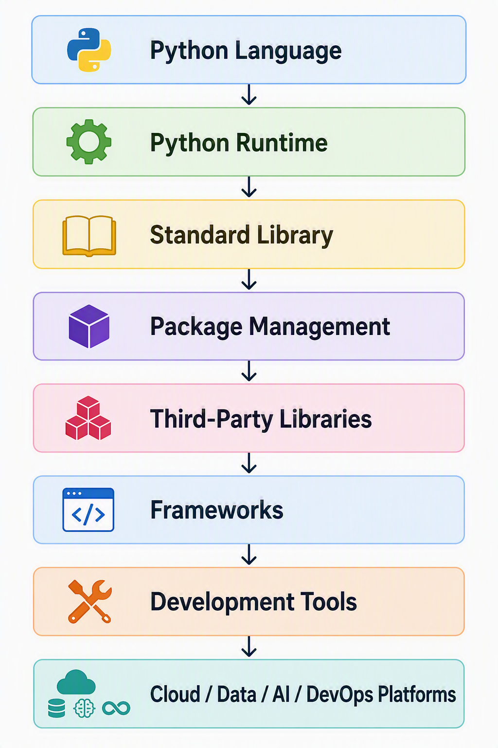
- Python Implementations
  - CPython
  - PyPy
  - Other implementations

- Python Standard Library
Area | Examples of capabilities
File handling | Reading and writing files
Operating system | Processes, paths, environment
Networking | Network communication
Data formats | JSON, CSV, XML-related functionality
Mathematics | Mathematical operations
Date/time | Dates, times and time zones
Regular expressions | Pattern matching
Databases | Database-related functionality
Testing | Unit testing
Logging | Application logging
Concurrency | Threads, processes and asynchronous programming
Compression | Working with compressed data

- Package Management
- PyPI
- Virtual Environments
- Python Standard Library

Environment Setup
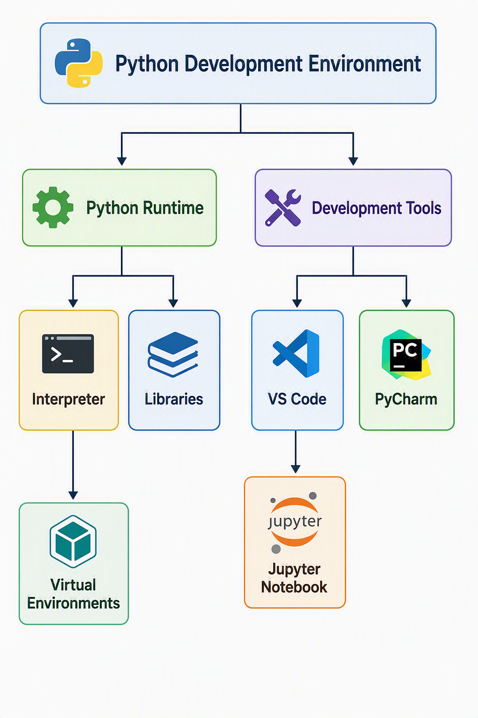
Python Fundamentals
Operators
• Arithmetic (+, -, *, /, %, //, **)
• Comparison (==, !=, >, <, >=, <=)
• Logical (and, or, not)
• Assignment (=, +=, -=, *=, /=, %=, **=, //=)
• Membership ( in, not in)
• Identity (is, is not)

Hands-on Labs
▸ Temperature converter
▸ Area calculator
▸ Currency converter
Assignment
• Employee salary calculator
Control Statements
Looping Statements
• for loop
• while loop
Loop Control
• break
• continue
• pass
List Comprehensions Introduction
It is a concise way to create a new list from an existing sequence or range.

Hands-on Labs
▸ Number guessing game
▸ Multiplication tables
▸ Prime number checker
Assignment
• ATM menu system

